Design of two Airfoils for a Canard Airplane
Martin Hepperle

For the airplane-project 'YAKA' (a development of the Ecole Supériore at Toulouse, France) two airfoils have been developed: Section MH200 for application in the main wing and section MH201 for the canard wing.

All results were obtained by using the Eppler-Code [1] for design and analysis of the airfoils. The design method of this code is based on conformal mapping while the analysis of various flap deflections is performed by a higher order panel method. Once the velocity-distribution is known, the drag-coefficients are calculated using an integral boundary layer analysis method. The lift- and momentum-coefficients from the potential theory are corrected for boundary layer effects (especially separation).

Section MH 200
The airfoil MH200 was designed to surpass the aerodynamic characteristics of the NACA 631-412 section while conserving maximum lift coefficient, momentum coefficient and at least retaining the thickness of 12 percent.

The results show some improvements:

- the increased thickness of approximatly 13 percent allows a weight reduction of the main wing structure.
- the laminar-bucket characteristics of the NACA 631-412 were avoided by incorporating a smooth change of transition location with variation of angle of attack α.
- the drag polars show improvements in the Reynoldsnumber range between 1·10⁶ and 8·10⁶ which should lead to better cruise performance of the entire aircraft. These effects were achieved without reducing the maximum lift coefficient or increasing the momentum coefficient.
- positive flap deflections up to 10 degrees allow shifting the region of minimum drag to a lift coefficient c_{l} = 1.0 while performing better than the NACA 631-412 airfoil.

- the same is true for negative flap deflections, moving the low drag region to c_{l} = -0.3 at a flap deflection of δ = -10°, thus resulting in lower drag in case of aileron and flap deflections.

Section MH 201
The airfoil MH201 was intended to replace the NASA GA(W)-2 airfoil. The airfoil shows a smoother drag polar at the same or lower drag coefficients than the GA(W)-2. Flap deflections are more effective when compared to the NASA airfoil.

Bibliography
[1] R.Eppler, D.Somers: ‘A Computer Program for the Design and Analysis of Low-Speed Airfoils’, NASA TM-80210, 1980
[2] R.J.Mc Ghee, W.D.Beasley: ‘Low Speed Aerodynamic Characteristics of a 13 Percent thick Airfoil Section designed for General Aviation Applications’, NASA TM X-72697, 1975

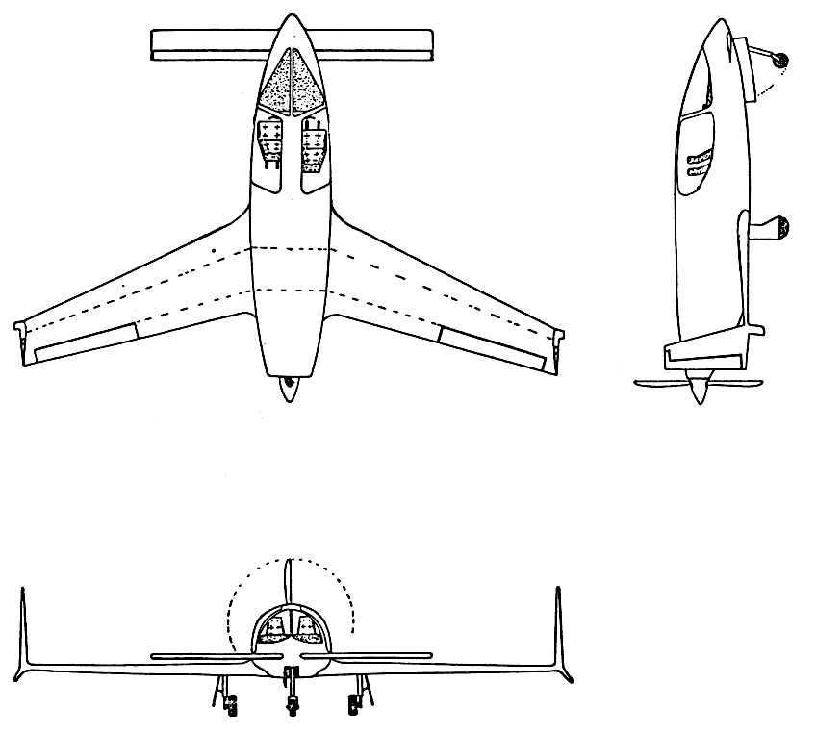
Fig.1: Three view drawing of the ‘YAKA’ project.

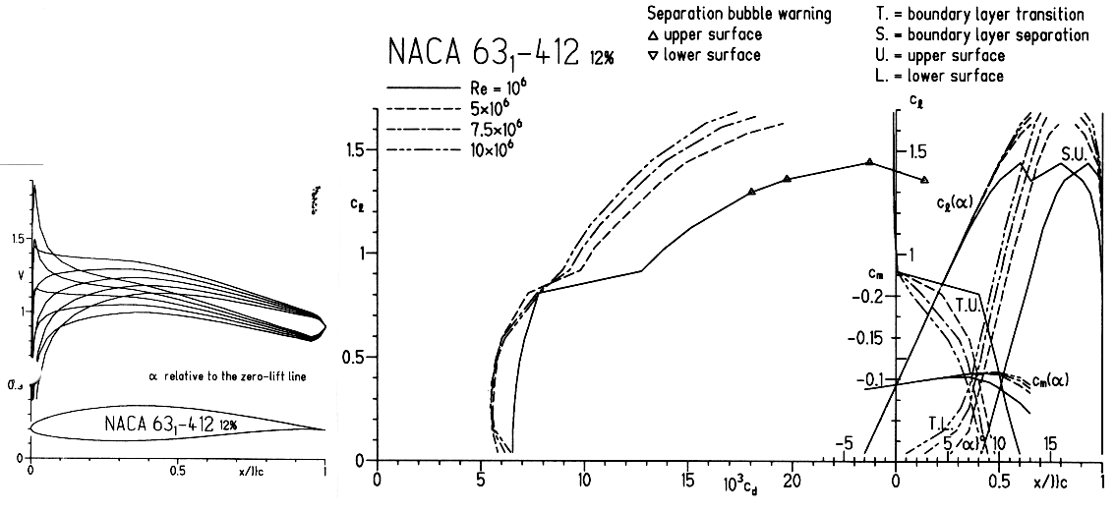
Fig.2: Velocity distributions and drag polars of NACA 631-412, smooth surface.

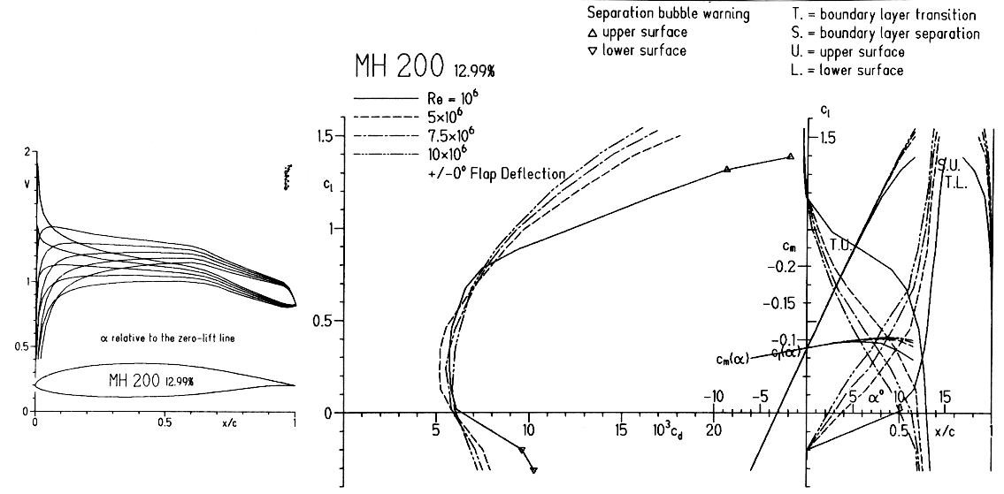
Fig.3: Velocity distributions and drag polars of MH 200, smooth surface.

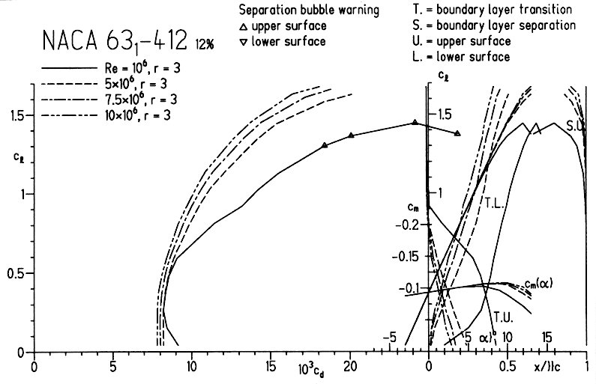
Fig.4: Drag polars of NACA 631-412, rough surface.

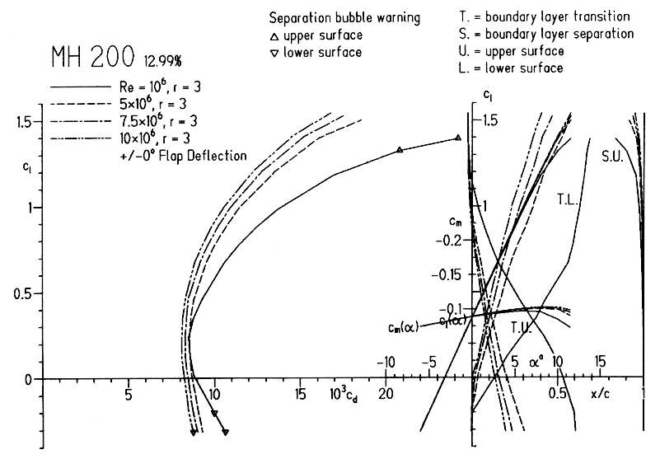
Fig.5: Drag polars of MH 200, rough surface.

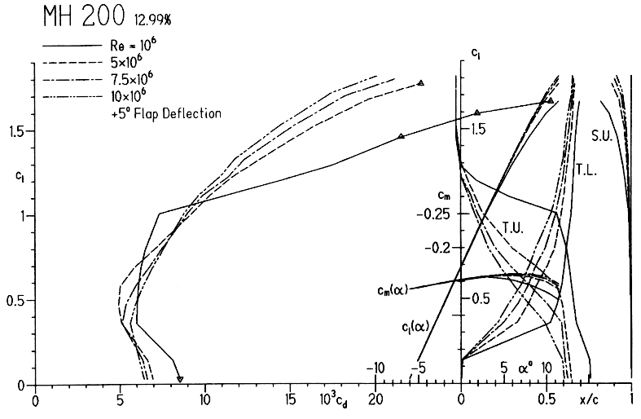
Fig.6: Drag polars of MH 200 with a flap deflection of +5°, smooth surface.

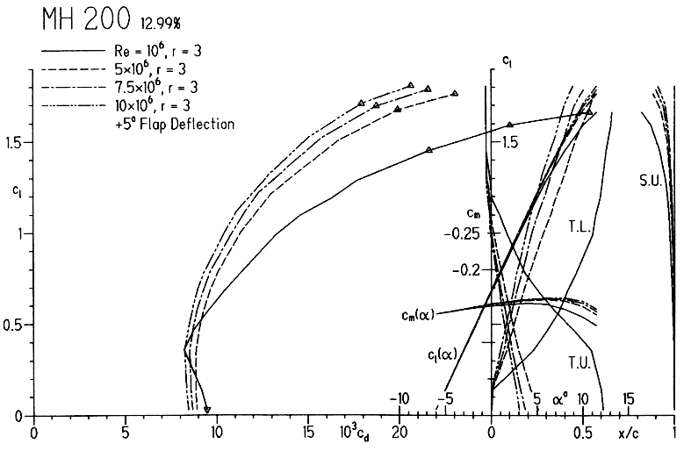
Fig.7: Drag polars of MH 200 with a flap deflection of +5°, rough surface.

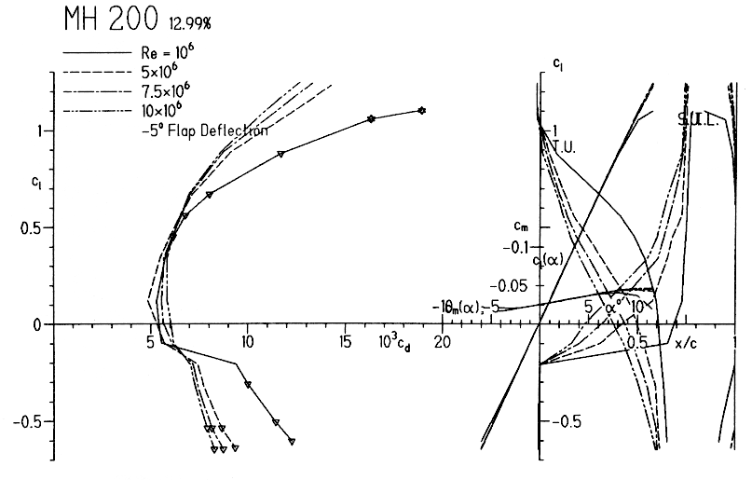
Fig.8: Drag polars of MH 200 with a flap deflection of -5°, smooth surface.

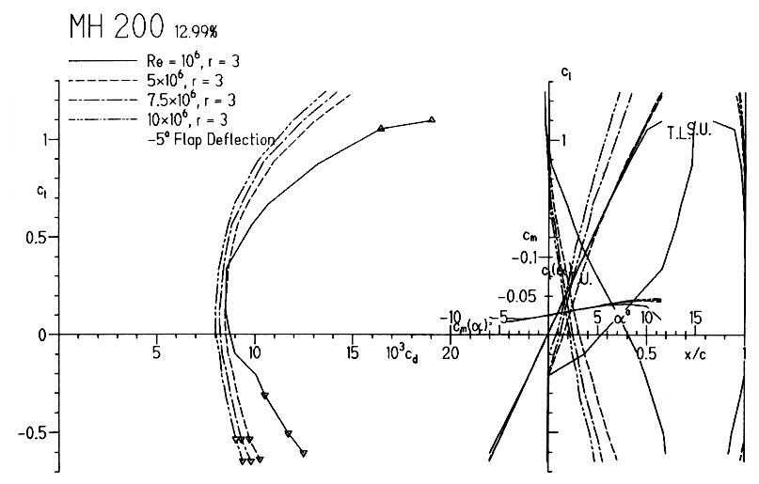
Fig.9: Drag polars of MH 200 with a flap deflection of -5°, rough surface.

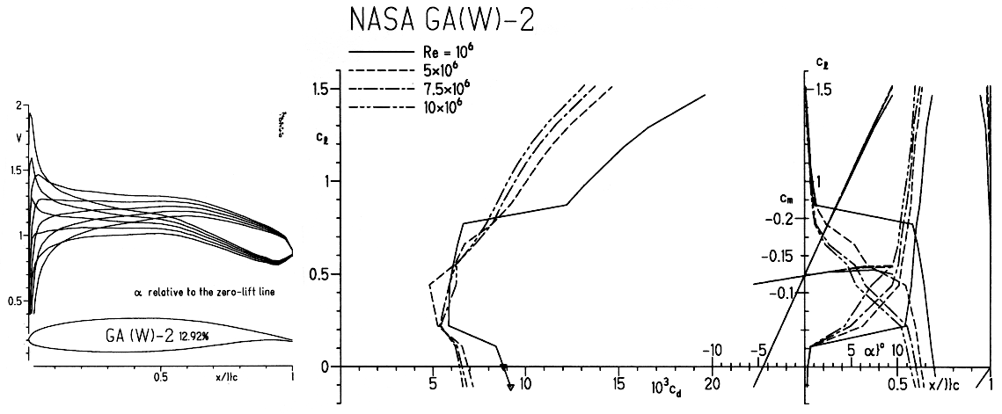
Fig.10: Drag polars of NASA GA(W)-2, smooth surface.

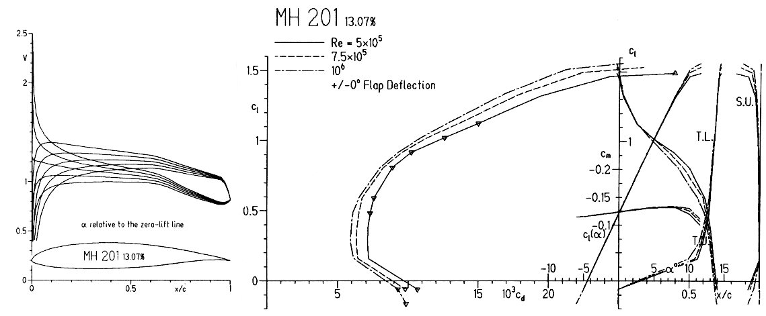
Fig.11: Drag polars of MH 201, smooth surface.

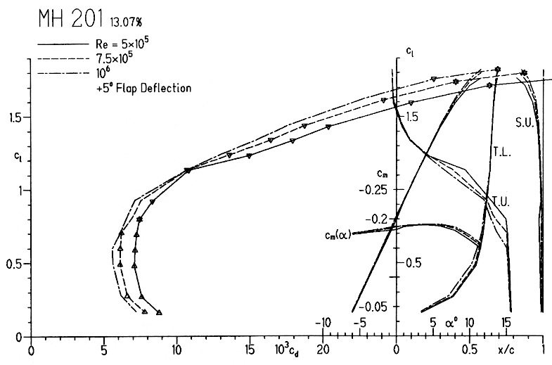
Fig.12: Drag polars of MH 201 with a flap deflection of +5°, smooth surface.

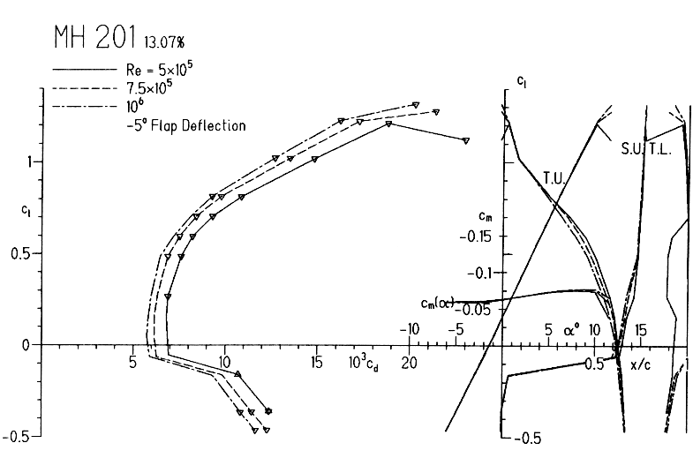
Fig.13: Drag polars of MH 201 with a flap deflection of -5°, smooth surface.

